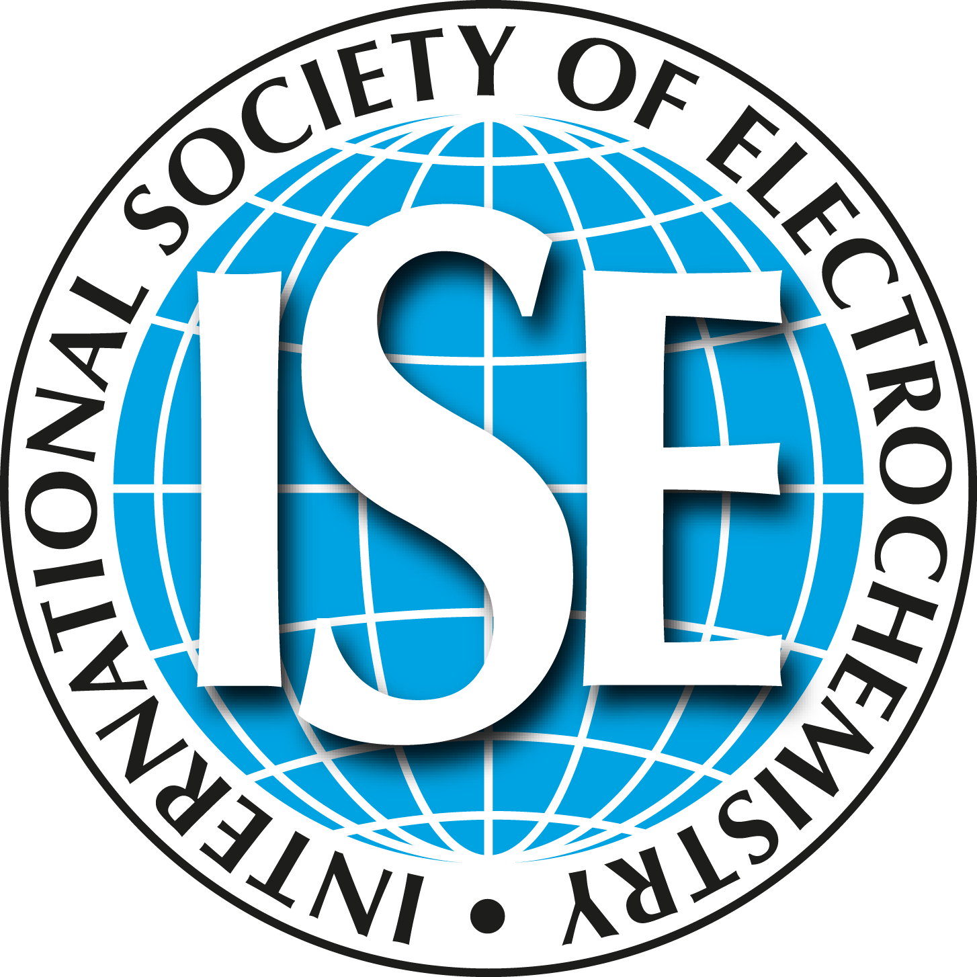 | International Society of Electrochemistry  Ch. du Closelet 2, 1006 Lausanne, Switzerland  e-mail: info@ise-online.org

Corporate and Corporate Sustaining Membership

Important: All fees are in EUROS.
Tick appropriate boxes, your name and address and e-mail this form to the ISE Office.

Membership fees
Corporate Members (includes Electrochimica Acta online) 300.00
Corporate Sustaining Members (includes Electrochimica Acta online) 500.00

Company Name: _____________________
Member ID: _______________________________ | Member ID: _______________________________
First name:________________________________ | First name:________________________________
Last name:________________________________ | Last name:________________________________
e-mail:____________________________________ | e-mail:___________________________________
Country:__________________________________ | Country:__________________________________

Mode of payment

By credit card
VISA MasterCard | Expiration date | Month: |  |  | Year:

Card number

Date: ____________________________ Signature:_______________________________

By Bank transfer

Remittance to: Bank: UBS SA, Case Postale, CH-1002 Lausanne, Switzerland
Account no: 287-M1224343.0
SWIFT code: UBSWCHZH80A
IBAN code: CH54 0028 7287 M122 4343 0

